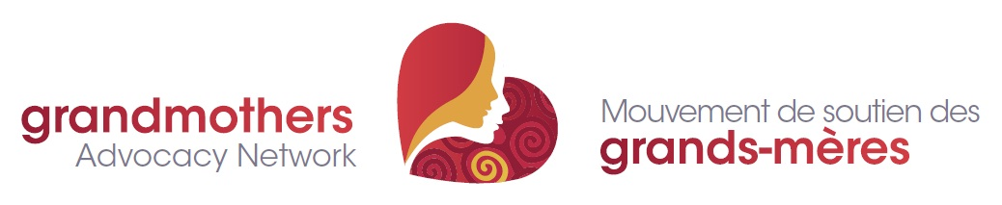

Advocating for grandmothers, vulnerable children and youth in sub-Saharan Africa
A Fair Shot Petition from Doctors Without Borders/MSF
to Glaxo Smith Kline and Pfizer asking them to reduce the price of the pneumonia vaccine.

To Pfizer CEO Ian Read and GSK CEO Andrew Witty:
A child dies of pneumonia every 35 seconds. Your companies, Pfizer & GSK, make an effective vaccine to prevent pneumonia but still 75% of children around the world remain unprotected against the disease. One key barrier is the high price.
Pfizer & GSK have already reported more than US$26 billion in global sales from the pneumonia vaccine alone. We call on you to lower the price to $5 per child for all developing countries and humanitarian organizations. It’s time to give all countries a fair shot at protecting the lives of their children.
NOTE: Your name will be added to the MSF Fair Shot Online Petition. Names will NOT be made public by MSF and e-mail addresses will not be shared publicly. *PLEASE PLACE CHECK MARK IN LAST COLUMN IF YOU WANT TO RECEIVE FURTHER E-MAILS ABOUT THIS CAMPAIGN from MSF.

# | FULL NAME(Print) | E-MAIL (PRINT) | Further e-mails? *
1
2
3
4
5
6
7
8
9
10
11
12
13
14
15
16
17
18
19
20
21
22
23
24
25
26
27
28
30
31
32
33
34

